Analysis 2

Problem Identification 2

Stakeholders 2

Interview 2

Research 3

Requirements 6

Functional Requirements 6

Non-Functional Requirements 7

Success Criteria 7

Design 8

User Interface Design 8

Main Menu 8

Generate Terrain Screen 11

Generate Heightmap 13

Load Heightmap 16

Decomposition 18

Algorithms 23

Indexing of Data 23

Calculating Vertex & Face Normals 24

Creating Faces 25

Creating Vertices 27

Creating Heightmap Image 28

Generating Noise (Perlin Noise) 29

Inputs & Outputs 30

Testing 32

Development & Testing 32

Evaluation 32

Criteria Met 32

Usability 32

Issues 32

Final Code 32

# Analysis

## Problem Identification

3D terrain is frequently used in 3D games and other projects (such as creating a fantasy world with lore behind it), however for smaller developers/hobbyists this is usually done by hand, which is very time consuming process, therefore the proposed software will allow for a small environment (terrain/planet) to be generated, with each time being a new, unique piece of land, intended for use in prototyping or worldbuilding.

Current solutions exist and are commercially available (such as World Creator and Instant Terra), however many are pricey (which may be an issue for many hobbyists who do not want to spend several hundred pounds for a piece of software), with many features which could overwhelm someone/not be necessary for prototyping purposes.

The proposed software would be used by small developers looking to prototype certain aspects of their game in a world (to see how it looks and interacts), as well as authors who want to create a fleshed out feeling world. On top of this, hobbyists would also find it useful for creating worlds to develop their games in.

The proposed system will manipulate a mesh, using several types of noise (i.e. Perlin and Worley) with controllable parameters to control things such as mountain quantity, terrain roughness and steepness, which will then be able to be viewed quickly, then exported as a Wavefront .obj file, which is able to be used in numerous programs, such as Blender and Unity.

The success will be measured as if the terrain is unique, the file is able to be exported, and the generation has controllable parameters.

### Stakeholders

## Interview

For my project, I interviewed a game developer who frequently makes small scale demos to test out certain features. They shall be referred to as Programmer A from hence forth.

Programmer A often makes small scale simulations and models in order to test out certain features for larger projects. Due to this, it is not feasible for them to create a map/piece of terrain by hand for each project, as this would be very time consuming. This makes them a good stakeholder as they would directly benefit from the tool, and their advice will likely be made with understanding of potential limitations.

**Question 1:** Have you used any 3D terrain generators before?

**Programmer A:** I haven’t used terrain generators, however I have used several character model generators. They are generally to complex for my use case, however.

**Question 2:** So would you prefer a simple program with fewer parameters?

**Programmer A:** That would be better for me, then I can create the terrain very quickly for my prototyping. Or I could maybe load in heightmap.

**Question 3:** Which programs do you intend to use the models in?

**Programmer A:** I use a few game engines, so Unreal (UE4), Unity and Godot. I use obj files for this currently, so that might be a good format to output in. I could also load it in Blender then to edit it further!

**Question 4:** Would it be beneficial if the terrain was coloured in some way?

**Programmer A:** That would be useful but if it was not I still wouldn’t be bothered. It may be interesting to add colours based off of height and steepness of the terrain in the future though.

**Question 5:** In terms of the size of the generated terrain, would it be useful to generate different sizes?

**Programmer A:** That would be nice, a chunk based system like in Minecraft would be interesting to use, but having different shapes, like 3x3 or 16x9, would certainly be useful.

**Question 6:** Would having different noises used in the generation be useful?

**Programmer A:** In certain situations that may be a useful feature to have access to, however for me that is not too much of a concern due to the use case I have.

**Question 7:** Is a preview of the terrain useful?

**Programmer A:** It would be useful, as otherwise I would have to navigate to where the file is stored and open it with 3D Viewer.

**Question 8:** And finally, would you prefer a web-based client or a program that runs on your machine?

**Programmer A:** Having a web based client would be really useful if I am working on a machine that is not so powerful, though it is not a necessity. It would be really interesting to see, however!

## Research

Currently, there are multiple solutions on the market, such as World Creator ([world-creator.com](https://www.world-creator.com/)) and the Low Poly Terrain Editor plugin for blender ([Low Poly Terrain Editor - Blender Market](https://blendermarket.com/products/low-poly-terrain-editor)). Both are paid for tools regardless of the use case. For non-commercial uses however, World Machine ([world-machine.com](http://world-machine.com)) is a free alternative which can be used, but can also be used in industrial settings using the paid license.

**Example 1: World Creator**

Overview:

World Creator allows for the real-time editing of terrain, which utilizes the GPU in order to increase the speed at which the terrain modifications can be completed and rendered. It is used by companies such as Blizzard and Ubisoft. As well as the creation of landscape, it also allows them to be painted in diverse colours and have trees and other vegetation added. It is compatible with many game engines (see photo).

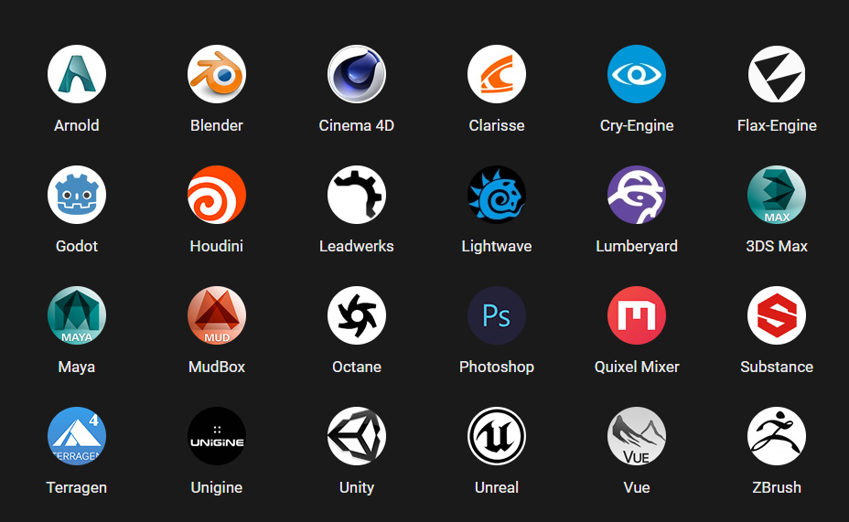

Taken from world-creator.com

Pros:

Editing can be done in real time, this makes it easier for the user to see how the variables that they are changing effect the overall terrain

Can be exported in .obj and .fbx file formats

Allows for manual editing of terrain

Uses GPU acceleration

Cons:

Costs - $289 for a fully featured Windows license

The program is crash prone (according to reviews of the software on Steam)

Has a very steep learning curve, making it hard to create good looking terrain for beginners to the software

**Example 2: Blender Low Poly Terrain Editor Plugin**

Overview:

This is a tool for the 3D modelling software Blender that allows low poly terrain to be edited. It has a selection of 5 stylised procedural textures that can be applied, in order to make terrain from different biomes. It also comes with low poly models that can be added to the scene in order to help bring it to life, as well as shaders for water and a skybox.

Pros:

Cost - $10 for the editor, or $39 for the editor and all other content

It is very fast to edit low poly, isometric and voxel terrains

Allows any model to be converted into these styles

Can be used to apply procedural textures of magma, snow, creeper, sand and terrain

Allows roads to easily be added to the terrain with editable paths

Allows the planting of trees

Enables ‘scattering’ of models over the terrain

Allows for the exporting of all supported file types by Blender (obj, fbx, 3ds, dxf, svg, stl, etc.)

Cons:

Only a small area can be generated and edited

Very slow to process tools such as the scatter tool

Only has the majority of features if the more expensive version is purchased

**Example 3: World Machine**

Overview:

World Machine is a program that is more centered around using algorithms to generate the terrain than to manually sculpt the whole thing by hand. Due to this, there are many customizable parameters with editable curves and modes that can be utilized in order to create the exact terrain wanted, however also allows for painting on top of this. It has been used in numerous games, as well as by independent artists.

Pros:

Edits made can be previewed in real time

Workflow is based on graphs, allowing for 8k resolution terrain generation instantly

Enables the creation of macros to speed up repetitive tasks

Allows changes to be undone and redone if necessary

Allows terrain to be generated from fractal noise

Allows the simulation of nature, such as erosion and water systems

Allows exporting in numerous file types (obj, tiff, OpenEXR) at a variety of resolutions

Can break the terrain down into ‘tiles’ for exports

Can be used for free

Cons:

To unlock all features, it will cost $1999 (Studio Site License)

Licenses only include 1 year of updates

Cheaper versions only support building with 2 cores (slowing down the export process)

|  |  |  |  |
| --- | --- | --- | --- |
|  | World Creator | World Machine | Blender Low Poly Terrain Editor |
| Price | $289 | Free/$119 | $10/$39 |
| Supported Export Filetypes | Obj, raw, png, fbx, bmp, tiff | Obj, tiff, png, OpenEXR | Obj, FBX, 3DS, DXF, SVG, STL, UDIM, USD, VRML, WebM, X3D |
| Allows manual terrain manipulation? | Yes | Yes | Yes |
| Uses parameter based workflow? | No | Yes | No |
| Allows props (trees, vegetation, etc.) to be added? | Yes | Yes | Yes |
| Allows water to be simulated? | Yes | Yes | No |
| Allows infinitely large areas to be generated? | Yes | Yes (dependent on version) | No |
| Allows terrain to be edited and previewed in ‘real time’? | Yes | Yes | No |
| Uses GPU acceleration? | Yes | Yes | Yes (For rendering the final result) |
| Allows the use of fractal noise in terrain generation? | No | Yes | No |
| Allows tiles to be exported? | No | Yes | No |

## Requirements

## Functional Requirements

* Can export .obj files, so that it can be used in most software (such as Unity & Unreal Engine 4), as requested by the stakeholder
* Can create a flat plane, so that it can be seen that the program works
* Must allow for the editing of certain parameters so that the terrain can be best suited for the user and their requirements, as requested by the stakeholder
  + Amplitude
  + Normal generation
  + Weighting of noise
  + Scaling of coordinates inputted to noise
  + Seed used for noise generation
  + Weighting of trigonometric functions
  + Scaling of coordinates inputted to trigonometric functions
  + Offsetting coordinates inputted to trigonometric functions
* Must allow for a ‘chunk-based’ system, allowing terrain to be infinite, similarly to the competitors
* Must allow for ‘chunks’ to be made of assorted sizes so that they can be utilized in any situation, similarly to the competitors (namely World Machine)
* Allows the use of a selection of different noises in order to create different styles of terrain
  + Perlin Noise
  + Worley Noise
  + Stacked Perlin Noise (Fractal Noise)
  + Heightmap
* Allows a preview of the terrain to be viewed so that the user knows what they will be exporting
* Preview allows camera rotation and panning, allowing the user to get a better view of the terrain
* The user should be able to select the location of the export and the file name

### Non-Functional Requirements

* Must have GUI that allows for parameters to be easily changed
  + Some parameters should have sliders and others text input boxes
* The GUI must explain parameters if needed

## Success Criteria

|  |  |
| --- | --- |
| **Criteria** | **How to Evidence** |
| Can export an .obj file | Screenshot and loading in Windows 3D Viewer without error |
| Can create a flat plane | When loaded, the surface is flat and shaded correctly |
| Must allow for editing of specific parameters | Video showing changing of parameters and the effect on the surface |
| Must allow for a ‘chunk-based’ system, allowing terrain to be infinite | Export consecutive ‘chunks’, load into 3D editing software and check they are continuous |
| Must allow for ‘chunks’ to be made of assorted sizes | Export different sized ‘chunks’, load into 3D editing software and check they are different sizes |
| Allows the use of a selection of noises | Video showing changing of noises and the effect on the surface |
| Uses trigonometric function to generate hills | Screenshot of a chunk which is a wavelength long, showing the curve |
| Allows a preview of the terrain to be viewed | Screenshot of viewer being opened and used |
| Preview allows camera rotation and panning | Video of these functions being used |
| User should be able to select the location of the export and the file name | .obj file can be saved to a folder, then opened from said folder |
| Illegal inputs are prevented | Only correct datatype allowed in each input |
| Clear error messages should be supplied | When illegal inputs are entered, they are clearly highlighted |

# Design

## User Interface Design

### Main Menu

In order to design the main menu, I split the screen into 2 types: constants and buttons. The buttons are then further split up into “Load Heightmap”, “Generate Terrain” and “Generate Heightmap”, as these will be all the functions that the software is able to provide. These can be seen in the following picture, with constants and buttons green and orange respectively.

I then prepared a design myself that made sense and would be possible to implement. The design had the constant at the top, and underneath was a 2x2 grid of buttons, with the bottom right slot being empty. If I implement this, I would fill this slot with a “Quit” button or something of the same effect.

After this was prepared, I asked Programmer A to try out the interface with the paper model. Initially, he tried the design and stated: “Whilst it is usable, I find that the empty gap leads to the GUI looking a little odd”. We then spent some time moving different elements around, until we settled on a design that placed all of the elements in a single column, with the buttons being on the bottom. It was determined that a “Quit” button was not necessary, as the window will not be full screen and has both “Minimise” and “Close” icons on the top right (as all Windows programs do). Programmer A suggested the order of “Generate Terrain”, “Generate Heightmap” and finally “Load Heightmap”, as he felt that this order would reflect the frequency of use between the different options. He also recommended that the differentiated colour between static elements and buttons be kept. The layout can be seen in the following image.

After creating this layout with Programmer A, I used Figma ([www.figma.com](http://www.figma.com)) to mock up the GUI and change colours to find an interesting yet not too contrasting colour scheme. I chose to maintain the different colours between the buttons and static elements, though I wanted them to be a similar colour so that they were clearly part of a consistent system. This resulted in using two different shades of a bright brown-orange colour on a blue background, creating a clear distinction between each element and the background, as well as between each element type, without creating a menu that puts strain on the user’s eyes.

I also tried adding curved corners to the different elements, allowing me to further differentiate between the buttons and the static elements with more than just colours. This change will allow my program to be more inclusive to people who struggle with colour blindness, as well as helping users understand the use of each element with more ease. Both this change and the colour scheme will be able to be carried forward onto the other screens, in order to maintain the consistent feel of the tool.

After designing in Figma, I then interviewed Programmer A regarding the new design. He was happy with all aspects, bar the colours, saying the GUI was simple and easy to use and understand. However, he found that the colours were too bright, though a good match, and suggested making them “duller of more pastel”. The GUI with the colour changes incorporated can be seen below.

After designing in Figma, I used Tkinter Designer ([TestTest4253/GUI-Designer (github.com)](https://github.com/TestTest4253/GUI-Designer)) to transfer the Figma design into Tkinter code that I could use within my project. The end result is as follows.

### Generate Terrain Screen

When designing the paper version of this GUI, I employed the same colour coding system as the one used for the main menu, however I also included a yellow colour for text input boxes. The buttons in this design are simply “Back” and “Generate”, however there are many more text input boxes. These are “X Size”, “Y Size”, “X Chunk”, “Y Chunk”, “Seed”, “Bias”, “Smoothing” and “Generate Normals”. These can be seen in the following photo.

Similarly to the process used when designing the main menu, I designed a sample layout for Programmer A to comment on. This layout placed the title (“Generate Terrain”), at the top, with “X Size”, “Y Size”, “X Chunk” and “Y Chunk” inline horizontally below it. The other text entry boxes were organized in a 2x2 grid below, with the “Generate” and “Back” buttons at the very bottom.

I then took my design to Programmer A in order to get him to use the design and comment on the user interface. Initially, he stated: “The menu is very usable as it is and I can easily tell what needs to go where. There do seem to be too many settings though, I can’t see that I would use X Chunk or Y Chunk very often at all”. We then changed the positions around until Programmer A felt that the design was as usable and aesthetically pleasing as could be. The result of this was “Generate Terrain” again being at the top, with “X Size”, “Y Size” and “Seed” on the row below, “Bias” and “Smoothing” on the row below that and finally “Generate Normals”, “Back” and “Generate” on the bottom row. However, Programmer A stated that it would be ideal if the text entry elements would have a background behind them, in order to differentiate between them and the buttons. This layout can be seen below.

After my meeting with Programmer A, I created a mock-up of the design in Figma ([www.figma.com](http://www.figma.com)). For the colours behind the static elements and buttons, I used the same colours as before. This helped me to create a consistent user experience between every window in the software, which should hopefully make the transition less jarring for the users of the software. However, I also had to decide on the colours to use for text entry fields and the background behind the text entry fields.

In order to maintain the use of colours to symbolise which elements are interactable and which are not, the colour of the text entry fields is the same as that of buttons. However, there is no text on the rectangle (unlike on button elements), instead labels use a small font positioned on top and to the left of the text entry fields. In order to further differentiate between the buttons and text entry fields, I added the change in background that Programmer A suggested. This was in the form of a purple square behind the text entry fields.

After creating this design, I sent it to Programmer A in order to get their feedback. They liked the design, as all elements were of the same colour and curvature of the previous menu. However, he stated that the background for the text entry fields would look better if it was, again, “duller” and “more pastel”, as well as if the rounding of the corners was smoothed out. The GUI with these changes made can be seen below.

After finalising the design, I exported the GUI to Tkinter using the same tool as last time, Tkinter Designer ([TestTest4253/GUI-Designer (github.com)](https://github.com/TestTest4253/GUI-Designer)). The final GUI can be seen below.

### Generate Heightmap

When designing the paper version of this GUI, I was able to reuse all components of the “Generate Terrain” GUI, with the only new component being a green “Generate Heightmap” constant. The components can be seen pictured below.

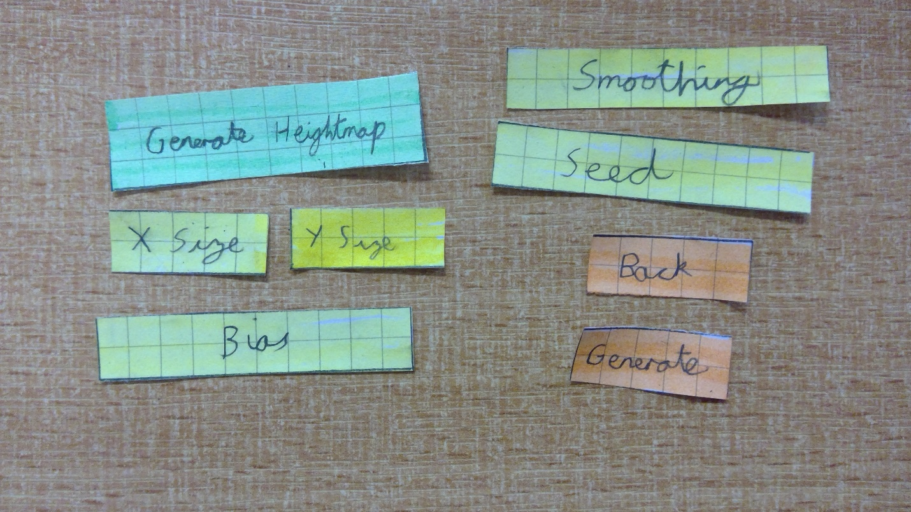

After procuring the components, I created a mock design to show Programmer A. This design had “Generate Heightmap” at the top, followed by “X Size” and “Y Size” on the same line, then the other text entry fields in a vertical column below. After the last text entry field, were the “Back” and “Generate” button, both on the same row.

I then took the design to Programmer A for feedback. He said that the design “was very usable”, however it did not mesh well with the “previously established design cues”. In order to make the menu match, we positioned “Generate Heightmap” again at the centre, with “X Size”, “Y Size” and “Seed” all inline on the row below. This was then followed by “Bias” and “Smoothing” on the row below, with “Back” and “Generate” on the final row. The completed layout can be seen below.

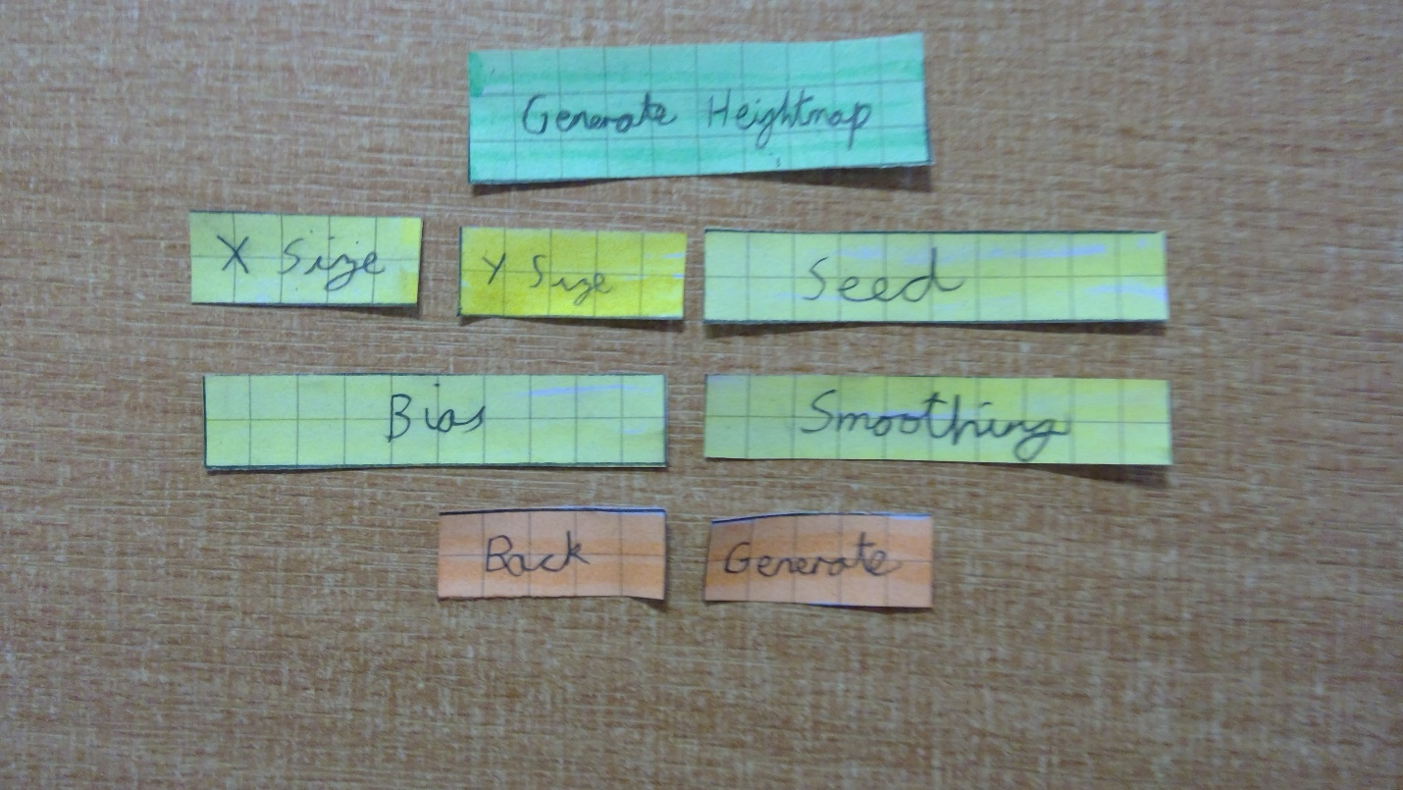

After finalising the layout with Programmer A, I started to implement the design in Figma ([www.figma.com](http://www.figma.com)). I utilized the same colours as with the previous two GUIs, as well as the same fonts. This will help to create a more natural looking experience for the user, as the screen won’t rapidly change colour to be a completely different look.

The shapes of all of the components are also identical, bar the purple background around the text entry fields. This was changed to be a rectangle with rounded corners, as opposed to a rectangle with a “chunk” taken out of one corner.

After finalising the design in Figma, I showed Programmer A. As all the colours were already the same as for the previous GUI, as well as the fonts and shapes, he was fine with it. The completed design can be seen below.

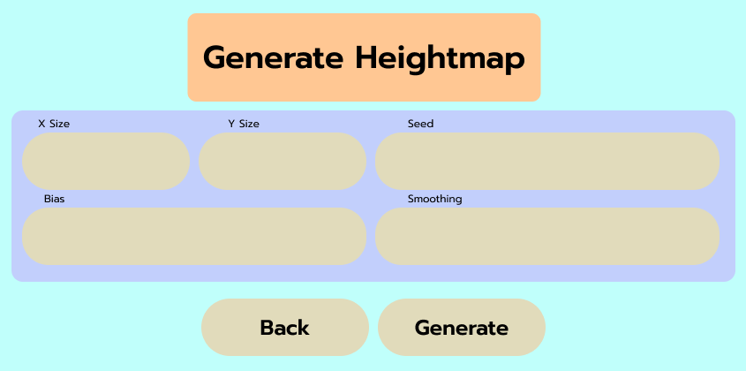

I then again exported the GUI to Tkinter using the same tool as last time, Tkinter Designer ([TestTest4253/GUI-Designer (github.com)](https://github.com/TestTest4253/GUI-Designer)). The final GUI can be seen below.

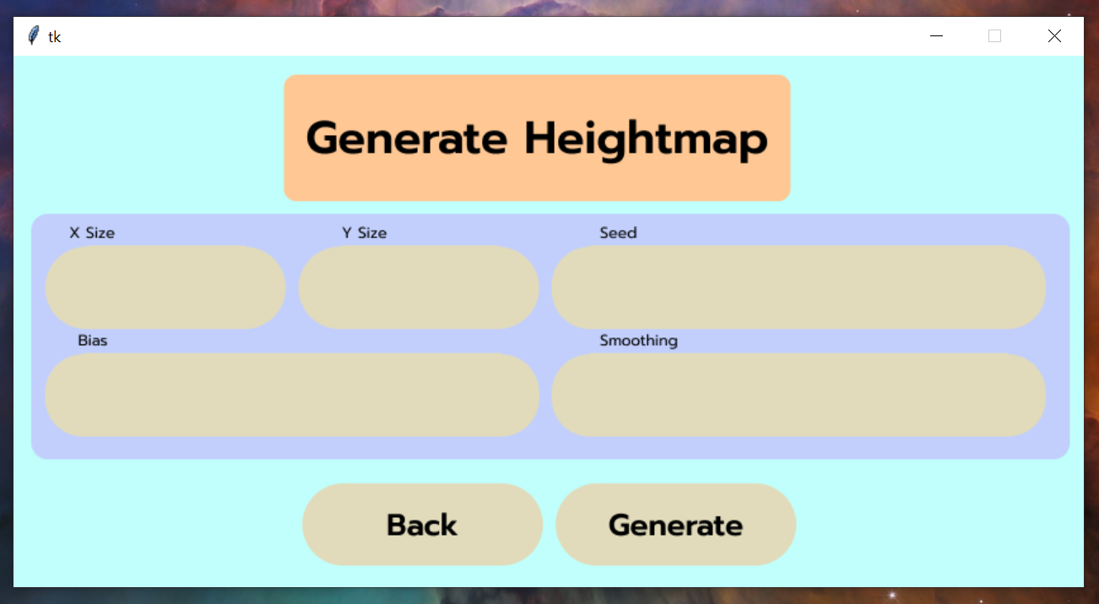

### Load Heightmap

Similarly to Generate Heightmap, Load Heightmap only needs one more component/element, this being the static “Load Heightmap” text. The other components are the “X Size”, “Y Size” and “Generate Normals” text entry fields, as well as the “Back” and “Generate” buttons. The elements can be seen pictured below.

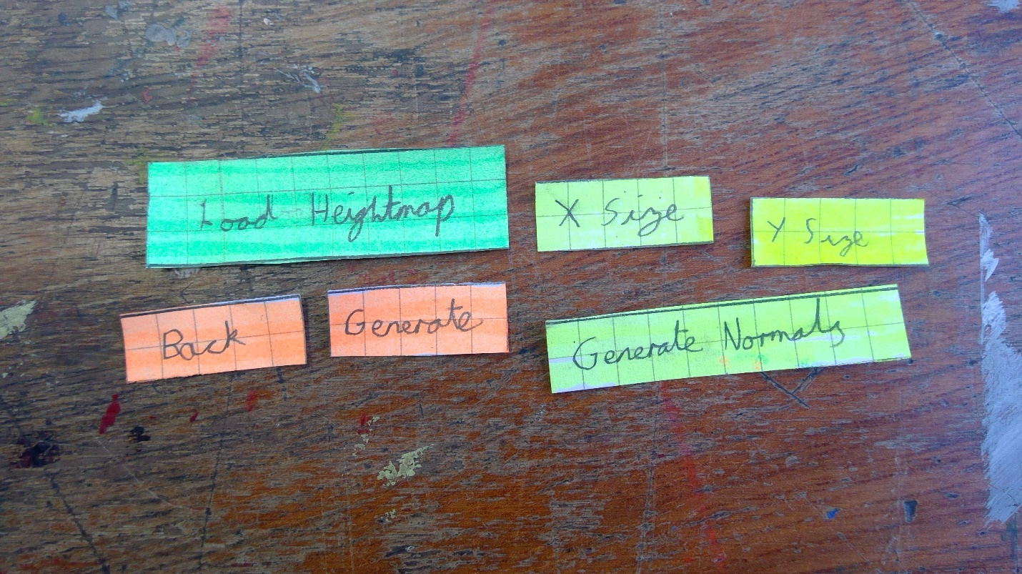

I then produced a design to show to Programmer A, with “Load Heightmap” again being at the top, with “X Size”, “Y Size” and “Generate Normals” in line on the row below. Underneath this the “Back” and “Generate” buttons could be found.

I took this design to Programmer A for feedback. He stated that the design was “ok”, but that it would look better if it was more similar to the design of the Generate Terrain screen, where the buttons are in line with the last of the text entry fields. To do this he suggested increasing the size of the “X Size” and “Y Size” text entry fields to be the same width as all of the other elements. This design (bar the increased width of text entry fields) can be seen below.

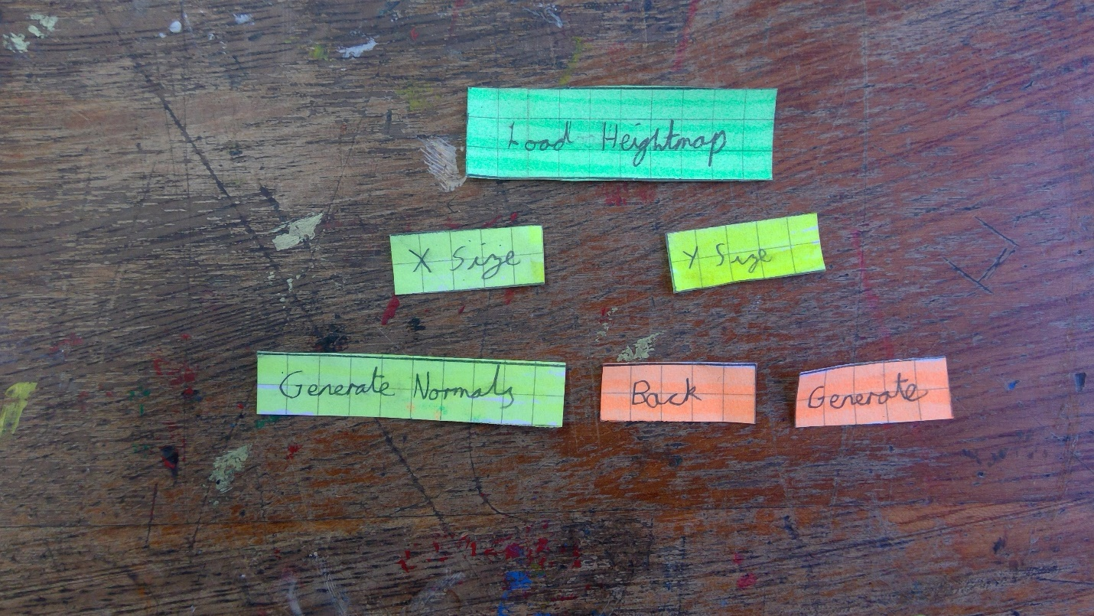

After finalising the layout, I recreated it in Figma ([www.figma.com](http://www.figma.com)). I used the same colours as the previous designs, and the same buttons sizes and designs, other than for “X Size” and “Y Size”, which both are increased in the X – Dimension.

The purple background is the same design as that on the Generate Terrain menu, with a rectangular “chunk” taken out of the bottom right. The only difference is that the height of the purple rectangle has been reduced by one element.

After finalising the design, I received Programmer A’s feedback. He felt that the design was very suitable, and fitted with the rest of the screens. This design can be seen below.

I again converted the Figma design to Tkinter using Tkinter Designer (<https://github.com/TestTest4253/GUI-Designer>). The completed GUI can be seen below.

## Decomposition

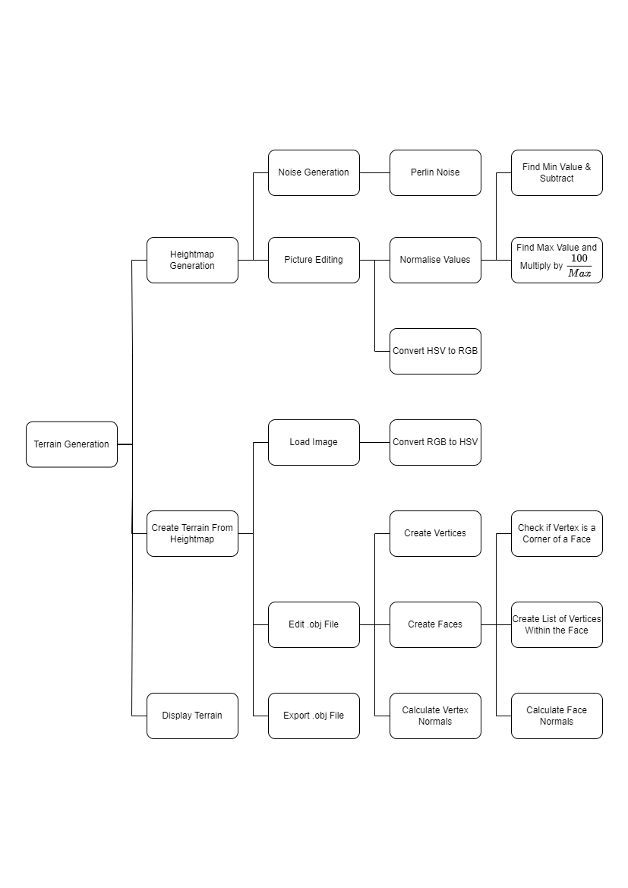

This method of decomposing the problem allows me to easily work on the three main components one at a time.

This will be imperative when I am working on the terrain editing (see “Create Terrain From Heightmap” on the diagram), as having separate heightmap generation will prevent me from accidentally breaking the Perlin Noise, for example.

As the terrain will also be generated from a heightmap, it will be easy to implement the functionality of using a predetermined heightmap, as this image will simply be a parameter that could be passed in. Whilst this is not on the success criteria table, Programmer A (the stakeholder) has requested this feature.

**On the Separation of Perlin Noise**

Having Perlin Noise as a separate module to everything else will allow me to quickly replace it if required. This will be very useful as for testing I will be able to use a function that will give me a pre-determined output for each coordinate, allowing me to more easily check that my terrain generation from heightmap is working. This will make testing much easier, and will potentially allow me to more easily bugfix the terrain generation components.

In addition to this, a testing function with a predetermined output will make it much easier to test that the image is being edited correctly. This is necessary as the value from the noise (which will represent the height of the terrain) will be used as the input for one of three values (Hue, Saturation & Value in HSV or Red, Green & Blue in RGB) that is given to each pixel in the image. If this is incorrect in the image editing segment, then it may result in colour banding or artefacts.

Colour banding is when there is a noticeable shift of colour in pixels along a line or edge in an image (see image below), resulting in a “band” appearing in the image. This could cause issues in my program, as the terrain generated from the image would also feature this band, in the form of a vertical face that would run along the terrain. This may not be as noticeable due to the low vertex resolution of the terrain that will be generated, however it is ideal if this is not the case, especially if the program is used in order to generate heightmaps.

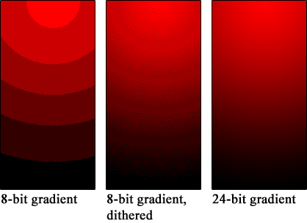

Image from Wikipedia: <https://en.wikipedia.org/wiki/Colour_banding>

Artefacts are also another issue that would negatively effect the production of terrain from an image. These are visual errors in digital graphics, an example from Windows XP can be seen below. Similarly to colour banding, these result in very sudden shifts of colour in pixels adjacent to each other. Due to the nature of terrain, this is not ideal as the terrain should be as smooth as possible, and artefacts could result in columns of terrain, or similar features.

An Artefact on Windows XP, taken from Wikipedia: <https://en.wikipedia.org/wiki/Visual_artifact>

Having Perlin Noise as a separate function also enables the type of noise to be easily changed, by simply replacing the algorithm (assuming that they both have the same outputs and function names). For example, the noise could be swapped out to Worley noise, in order to produce varying terrains including a variety of different features (a comparison of Worley Noise and Perlin Noise can be seen below).

Left: Worley Noise, take from Wikipedia: <https://en.wikipedia.org/wiki/Worley_noise>  
Right: Perlin Noise, generated by my program

The implementation of Perlin Noise I will use is a direct translation of Ken Perlin’s original implementation into Python. The noise will be used within a class (NoiseFactory) which will have getters and a function for octave noise on top of the Perlin Noise. Octave noise is based off of Hugo Elias’ definition of persistence (Source: [Perlin Noise (arendpeter.com)](https://www.arendpeter.com/Perlin_Noise.html)).

NoiseFactory UML Diagram

The functions and variables will be explained within the algorithms section on Perlin Noise, bar list[]. This array allows the values generated by the noise algorithm to be stored, and in turn accessed at any time. This should help to optimise the program, as the noise only has to be generated once, as opposed to other systems that may result in noise being generated for every point multiple times.

**On the Separation of Normalising Values**

When the Perlin Noise algorithm outputs values for all pixels, they will likely be over a wide range of values. These values can include negative numbers, have no negatives, and extend to much higher numbers in certain circumstances. This is not ideal, as if I use a HSV image to store the value for each vertex (where each vertex is represented by one pixel) then I will only have 100 different colours to use, assuming that only the Value data is used, as this is a float between 0 and 100 inclusive.

In order to have the most detail possible in the terrain whilst still maintaining a reasonable file size, I need to make sure that every value in the output is between 0 and 100. In order to do this, I will take the smallest value within the array of values produced by the noise algorithm and subtract it from all values. Then I will divide every value by the maximum value in the array, and multiply by 100, resulting in the values being normalized.

Having this as a separate function will allow me to quickly change this to a larger range, for example 0 – 255. This is useful if I want to be able to store more detail within the image so change to use RGB. Furthermore, it will also allow me to change the normalisation to use other values within the HSV declaration, further increasing the versatility of the program.

**On the Separation of Normal Calculation**

In order to use certain features in .obj wavefront renderers, such as Phong shading, vertex normals are required. These are values that allow the renderer to smoothly interpolate the lighting used, which can result in a model looking rounder than it actually is (see below). Having this as a separate function allows me to disable or enable this feature at will, in order to create low-poly terrain or terrain that appears more detailed.

Flat shading (left) vs Phong shading(right). Taken from Wikipedia: <https://en.wikipedia.org/wiki/Phong_shading>

## Algorithms

### Indexing of Data

In order to be able to easily access all data, it needs to be stored in a standardized format that is optimised for the procedures that it will perform.

Vertices will be stored in an array of length $X scale×Y Scale$. Each vertex will itself be an array of length three, containing the data of coordinate and noise value in the form [x, noiseValue, y]. Each vertex array will be have the index of $X coordinate+Y coordinate×X scale$ within the vertices array. When the vertices are in the .obj file they will be indexed at their vertices index plus 1.

Faces will be stored in an array of length $2×\left(X scale-1\right)×(Y scale-1)$. Each face will itself be an array of length three, where each element in the face array is a vertex (which subsequently has three values, as described in the above paragraph). When they are in the .obj file, they will be indexed at their faces index plus one.

Face normals will be stored in an array of length $2×\left(X scale-1\right)×(Y scale-1)$. Each face normal will itself be an array of length three, where each element is the X component, Y component and Z component respectively. These will not be contained within the obj file, but instead used for creation of vertex normals.

Vertex normals will be stored in an array of length $2×\left(X scale-1\right)×(Y scale-1)$. Each vertex normal will itself be an array of length three, where each element is the X component, Y component and Z component respectively. When they are in the .obj file, they will be indexed by their index in the vertex normals list plus one.

### Calculating Vertex & Face Normals

In order to calculate the vertex normals, the face normals first have to be calculated. In order to use this, we take the coordinates of the vertices that make up the face. We can then calculate the vectors of two edges of the triangle, and take the cross product of these. This can then be turned into a unit vector by dividing each component by the magnitude of the normal. See a worked example below.

**Example:**

Vertex 1: (0, 1, 2)

Vertex 2: (0, 1, 1)

Vertex 3: (0, 0, 1)

Edge 1:

${E_{1}= V}_{2}-V_{1}=\left(0, 0, -1\right)$

Edge 2:

$E_{2}=V_{3}-V_{1}=\left(0, -1, -1\right)$

Face Normal:

${N= E}_{1}×E_{2}=(-1, 0, 0)$

$|N|=\sqrt{{\left(-1\right)}^{2}+0^{2}+0^{2}}=1$

$∴N is (-1, 0, 0)$

After all face normal have been calculated, we can then iterate through every vertex and store all the faces that it is part of. The normals of these are then added together in a vertex normal array, where array[0] is the x coordinate, array[1] y and array[2] z. This then needs to be turned into a unit vector by finding the magnitude and dividing every component by this.

Finally, as we are generating terrain and this will always be on the floor, we need to make sure that the y component (array[1]) is positive. If negative, we need to take every component and multiply by -1. This is the final vertex normal for the point.

**Pseudocode:**

### Creating Faces

In order to create faces, we first have to find out which vertices have space to be in the lower left corner of two different triangles (see circled corners on diagram below). We can then find out which vertices that are also on available faces, and add an element to a list of faces that contains all 3 of these vertices.

The reason we check that each vertex is part of a triangle is because the terrain will be made up of lots of triangles. This allows us to have more detailed and natural looking terrain than if squares were used, whilst also maintaining the low poly style of terrain that is desired.

Finding the other vertices in the face is simple, as all vertices are stored in a one dimensional array, with an index of $X coordinate+ Y coordinate×X Scale$. This means that all we need to do is take the index of the vertex in the list $vertices$, and add or subtract a specific number. For the vertex above, we simply subtract $xscale$, and for the vertex to the right we add 1. We can then return the vertex in that index in $vertices$, and use this in the face.

This is a much simpler method than the alternative, which involves manually creating the vertices added to the face by creating them from the X and Y coordinates of the first vertex, and then finding the value of the noise at these new coordinates. This could result in rounding errors (depending on the parameters used), which would result in a much more complicated system that occasionally will return errors and break the program.

**Pseudocode**

### Creating Vertices

In the pseudocode, I will reference a library “perlin”. This is the noise class that I will use (see Perlin section in Pseudocode), though it can be replaced with a different noise class with the same output.

In order to create a list of all vertices, we first need to calculate the values of the noise at each pixel. Once this is done we can then run through two nested loops and create all necessary vertices. We will only create the vertices that make up the top face, as these are the only vertices that would be seen if the terrain is used in a game, and adding other vertices would slow down both the creation and viewing of terrain, as the number of faces would be slightly over doubled.

When we insert the vertices into the list however, we need to make sure that they are inserted in a way that gives them the correct index, which in this case is $X coordinate+Y coordinate×X scale$. If this is not done correctly, other algorithms will break or have to be much more complicated in order to take into account the different order.

**Pseudocode**

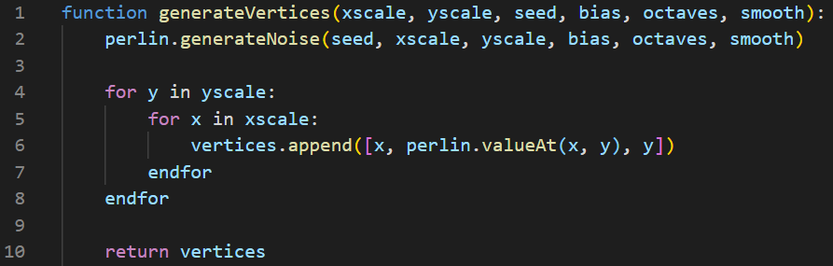

### Creating Heightmap Image

To handle images in my project I will use the Python library Pillow ([python-pillow/Pillow: The friendly PIL fork (Python Imaging Library) (github.com)](https://github.com/python-pillow/Pillow)). This allows me to create, edit and access images. In the pseudocode I shall use functions that it provides, and reference them as pillow.FunctionName().

I will also reference a library “perlin”. This is the noise class that I will use (see Perlin section in Pseudocode), though it can be replaced with a different noise class with the same output.

In order to create the image used as a heightmap, we first need to generate the noise. In this example I will use Perlin Noise, as it is the one I will use, but ideally every type of noise can be made to return in the same manner and with the same indexing. For example, “perlin” could be replaced with “worley” and it would still function in the same way, just creating a different looking heightmap.

After the noise has been calculated, we then need to set the pixel in the image which represents a coordinate to the value of the noise at that coordinate. This can be done by drawing a square at position (X, Y) which has side-lengths of 1. As I am using HSV to store the image in greyscale, I then set the colour of this square to (0, 0, noiseValue).

The HSV image must be converted into RGB before it can be saved. Finally, it can then be saved.

### Generating Noise (Perlin Noise)

In my initial tests, I will use Perlin Noise so the explanation and pseudocode here will be based off of Perlin Noise, however it is interchangeable with another noise type, such as Worley Noise or even random noise. I shall reference the following UML diagram in the explanation.

The permutation array stores all numbers from 0 to 255 inclusive, in a random order. In this case, the order will be the same as Ken Perlin’s original implementation as that was shown to give good results. When the class is initialised, the array p will be populated with the numbers from permutation, with every number being included twice.

When the noise is generated, the algorithm checks which 1 by 1 “grid cell” the point is within. It then calculates the relative position within this grid cell. A vector for each corner of the cell is pseudo-randomly generated (this results in the same grid cell corners always having the same vectors associated with them, assuming that the same seed and permutation table is used). The algorithm next dot products the vector and the displacement gradient. Finally, we interpolate the dot products in order to return the value at that point.

Octave noise allows for smoother output images. In order to create octave noise we need to generate Perlin Noise with a number of different frequencies and amplitudes. In order to scale these correctly, I will use Hugo Elias’ definition of persistence:

$frequency=2^{i}$

$amplitude=persistence^{i}$

In this definition, $i$ is the octave being calculated. Persistence is a variable that can be tweaked in order to control the smoothness of the output.

A comparison of different values of amplitude, taken from <https://www.arendpeter.com/Perlin_Noise.html>

**Pseudocode** (For Octave Noise)

## Inputs & Outputs

**Generate Terrain**

The program will take no input files, however the user will be able to input data through a GUI menu to the program, from which the terrain will be generated.

The inputs will be:

* X Scale
* Y Scale
* Seed
* Bias
* Smoothness
* Generate Normals
* Location to save to
* File name to save to

The program will then output a file, which will be a .obj file containing the generated terrain.

**Generate Heightmap**

The program will take no input files, however the user will be able to input data trough a GUI menu to the program, from which the heightmap will be generated from.

The inputs will be:

* X Scale
* Y Scale
* Seed
* Bias
* Smoothing
* Location to save to
* File name to save to

The program will then output a file, which will be a .png file containing the generated terrain.

**Load Heightmap**

The program will take 1 input file, as well as allowing the user to be input data through a GUI menu, and will then use all data collected to generate terrain from the heightmap.

The inputs will be:

* A png heightmap
* X Scale
* Y Scale
* Generate Normals
* Location to save to
* File name to save to

The program will then output a file, this being a .obj file containing the generated terrain specified by the heightmap.

## Testing

# Development & Testing

# Evaluation

## Criteria Met

## Usability

## Issues

# Final Code